File permissions in Linux

Project description
I work with research team in a large arenization. Part of my job is to ensure users on this team are authorized with the appropriate permissions. This helps keep the system secure. my task is to examine existing permissions on the file system. I determine if the permissions match the authorization that should be given. To complete this task, I performed the following tasks:

Check file and directory details
I used Linux commands to determine the existing permissions set for a specific directory in the file system.
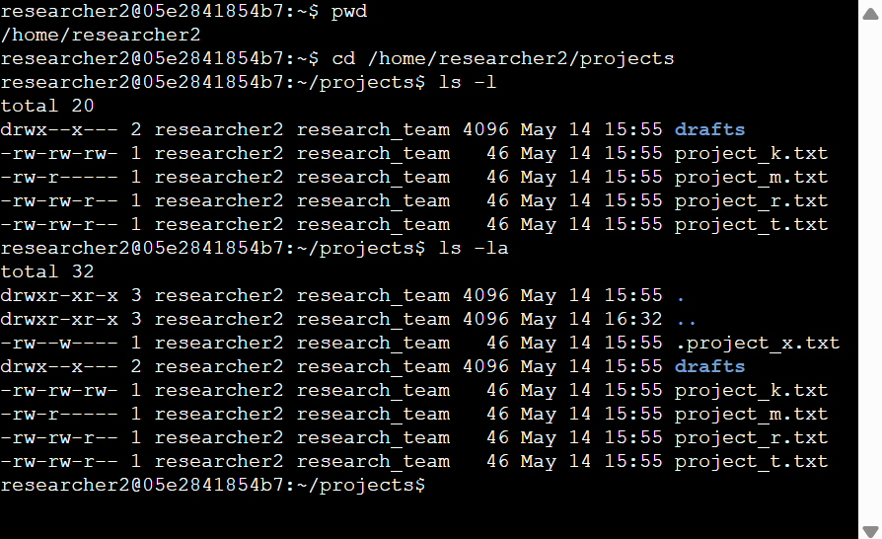

First code I entered is {pwd} which display what directory I am currently working ,I need to lists all contents of the projects directory and to do that first I navigate to “projects Directory” using {cd /home/research2/projects} then to list the content I enter {ls -l} and to show the hidden file as will I enter {ls -la} command. it includes one hidden file named .project_x.txt, and five other project files. The 10-character string in the first column represents the permissions set on each file or directory.

Describe the permissions string

A 10-character permission string tells you what type of file it is and who can do what with it. Here’s how to read it:
- 1st character: Shows the file type.
  - d = directory
  - - = regular file
- 2nd–4th characters: User (owner) permissions — read (r), write (w), execute (x).
  - A - means the user does not have that permission.
- 5th–7th characters: Group permissions — same rules: r, w, x, or -.
- 8th–10th characters: Other permissions — what everyone else can do.

Example: -rw-rw-r--
- The first character is -, so project_t.txt is a regular file.
- The user, group, and others all have read (r) permission.
- Only the user and group have written(w) permission.
- No one has executed(x) permission because there are no x’s in the string.

Change file permissions

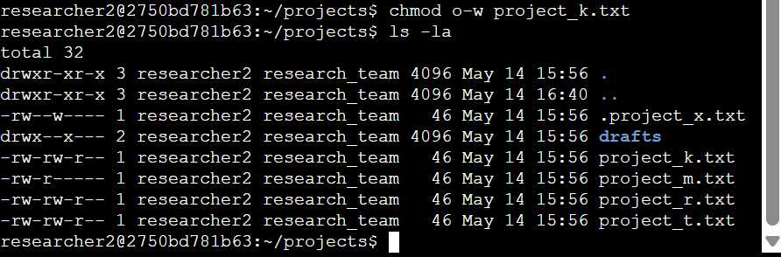
The organization does not allow others to have write access to any files. Based on that I identify which file needs to have its permissions and modify the permissions.

The following code demonstrates how I used Linux commands to do this:
The first command is {chmod o-w project_k.txt} file to change the promotion and remove write permissions from others, I used {ls -la} to review the updates I made.

Change file permissions on a hidden file

The research team has archived .project_x.txt, it’s a hidden file. This file should not have write permissions for anyone, but the user and group should be able to read the
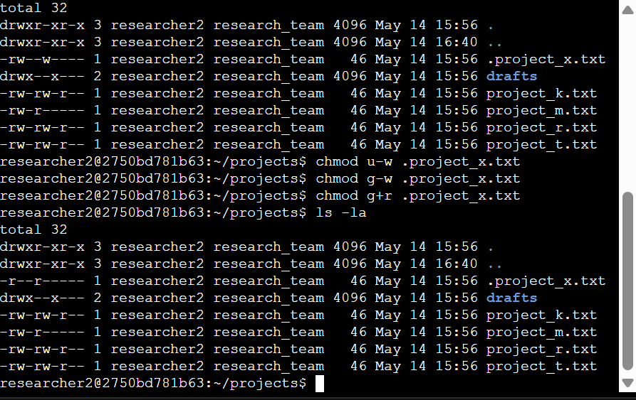
file.

The first three lines of the screenshot show the commands that I removed write permissions from the user and group {u-w} {g-w}, and added read permissions to the group {g+r}. {ls -la} to review the updates I made.

Change directory permissions

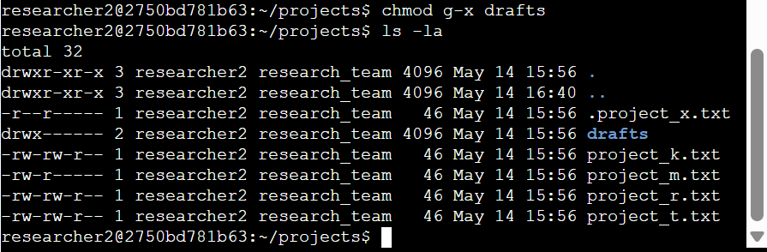
The files and directories in the project’s directory belong to the researcher2 user. Only researcher2 should be allowed to access the drafts directory and its contents.

At the first line I ran the command {chmod g-x drafts} to remove the execute permission from the groups

Summary

To examine existing permissions on the file system, the first step in this was to use the {ls -la} command to check the permissions for the directory, I changed multiple permissions to match the level of authorization that my organization wanted for files. I used the {chmod} command multiple times to change the permissions on files and directories, following the organization's guidelines.

